**↠PHANTOM Central Hub↞**

**Approved by: Senior Ranks from TR | Phantom**

Written by former Phantom MR, Adrián Martín Vázquez (A.K.A PacoAlmodovar).

■▬▬▬▬▬▬▬▬**【INDEX】**▬▬▬▬▬▬▬▬■

[#1] – REQUIREMENTS SPECIFICATION

[#1-1] - Project description

[#1-2] – Project goals

[#1-3] – Client Group Description

[#1-4] – Client Requirements

[#1-5] – Personas

[#1-6] – Research on Competitors

[#2] – PLANNING DEVELOPMENT

[#2-1] – Gantt chart

[#2-2] – Budget

[#3] – DESIGN

[#3-1] – Sketch

■▬▬▬▬▬▬▬▬**【/INDEX】**▬▬▬▬▬▬▬▬■

# **[#1] – REQUIREMENTS SPECIFICATION**

■▬▬▬▬▬▬▬▬▬▬▬▬▬▬▬▬▬▬▬▬▬▬■

## **[#1-1] - Project description**

**This project centralizes the interests and activities of the members of a Roleplay group on a single website, where they can find information about events, Unit of the Week, clips, combat strategies from training events, tutorials, and guides on becoming the stealthiest unit. In short, it’s a website that gathers all the information about this group, which is currently scattered across Discord chats, Roblox groups, and other social media platforms.**

**It will serve as an index for all types of information related to the roleplay and will be helpful for PHANTOM units (members). Additionally, it will include a link to view their uniforms and access their private training facility game (**[***HOLO***](https://www.roblox.com/games/6727543635/PHANTOM-Holo)**).**

■▬▬▬▬▬▬▬▬▬▬▬▬▬▬▬▬▬▬▬▬▬▬■

■

## **[#1-2] – Project goals**

**The project's purpose is to recruit more people, as the roleplay group desires increased activity. Therefore, the main goal is to boost the division's popularity, activity, and professionalism, as well as that of the game itself.**

* **Measures to be taken to achieve this:**

**To make this possible, the website will spread propaganda through ads on various platforms, as well as on the Home Page. Once a visitor with interest clicks on "visit our website," they will be directed to a page with a tactical or military design that aligns with the division's theme (Home Page ➜ About Us), drawing them into the website's topic.**

**Additionally, descriptions will be crafted professionally, and there will be a strong promotional effort to encourage visitors to join the group through videos, tutorials, guides, and forums. Notifications will pop up for those who register or log in to the website with the user registration system, and optional email adverts will be available for those who subscribe.**

**As mentioned, the primary focus will be on newcomers visiting the site. For this reason, the Home Page will include not only propaganda and ads, but also explanations of what Phantom is, the lore/history of the roleplay, promotional content, and reviews from other players about the game and the roleplay group.**

**To conclude, Phantom will add more sections where they can find events, Unit of the Week, clips, courses for new LUA developers in the Holo, links to the uniforms and games, etcetera.**

**With these measures and advertisement on different platforms, Phantom aims to attract an audience of 16 years old to 30 years old who enjoy stealth military content, who help increasing the** **average number of active players to a 15% more than it was in July which it was 100 players active on the Roleplay Game City-17, also Phantom wants to increase their community members too for more activity, from 25 members to 50 members at least, and more developers that want to work on their games for a reasonable price, they want to increase their developers from 3 that it is right now, to 10 and make a group of 5 working on the Roleplay games, and other 5 working on the HOLO.**

■▬▬▬▬▬▬▬▬▬▬▬▬▬▬▬▬▬▬▬▬▬▬■

■

## **[#1-3] – Client Group Description**

**PHANTOM is a divisional subgroup of a larger open community called “The Robine”. PHANTOM, however, is a private group that requires specific criteria to be met for recruitment or invitation. This group functions as a clan and participates in Roblox Combat League (RCL) tournaments, where they win prizes in money or Robux (the virtual currency from Roblox that can be converted to real money). They also engage in roleplay games within the main community, "The Robine". In these games (such as** [***City-17***](https://www.roblox.com/games/509062192/CORE-UPDATE-CITY-17)**,** [***City Reborn***](https://www.roblox.com/games/17835552135/C17-City-Reborn)**, and** [***Downtown RP***](https://www.roblox.com/games/125278189013070/Downtown-RP)**), PHANTOM operates as a Stealth Task Force, acting as "spies”. Also, there are a few of their members who are developers of one of these games and the private training facility of Phantom (HOLO). They program in LUA which is a language for sandbox games.**

**They also spread propaganda for both their divisional group (PHANTOM) and the main community (The Robine) to gain recognition within the broader Roblox community.**

**Their philosophy revolves around their motto: “Strike when they least expect it!” This applies not only for roleplay purposes but also as a strategy to maintain their community by seizing any opportunity that comes their way and turning it into reality. This is how they envision making this website a reality. And is how they wanted to prevail on the future.**

**[*This was all extracted from a meeting with the commander and owner of Phantom AdabWhen, and his Vice-commanders, tepigater and IamdeadX_XdaedmaI*]**

■▬▬▬▬▬▬▬▬▬▬▬▬▬▬▬▬▬▬▬▬▬▬■

■

## **[#1-4] – Client Requirements**

**Our SRs (Senior Ranks) from “The Robine” specify the content they want to add to the page. They have also provided me with some posts to start with. The following sections contain a variety of items that are listed:**

**>> HOME PAGE: This main page of the entire site will contain promotional material to encourage people to join the division, as well as explanations of what we do and other elements to attract you to our roleplay group. At the bottom of the page, there will be links to some of the sections you can explore within the site.**

**>> Announcements: This is an aside section that reports announcements posted by Senior Ranks through various channels regarding new regulations or updates for the community and the benefit of the Phantom group. This section is controlled exclusively by SRs and is divided into "versions." Additionally, announcements from the game developers will also be posted here.**

**>> Information: This is a footer section for visitors who may need more details before deciding to join. It serves as a reference for other documents where people can download or view additional information on external pages not directly related to the website. These documents explain important aspects of the group, such as rules, links to our game, and more.**

**>> Events: In this section, there will be events scheduled by Higher Ranks for both current and former PHANTOM units to help boost activity.**

**>> PEP (Phantom Entrance Program): This is a sub-page of the main events page. Here, visitors can apply to join the division. If selected, they will be redirected to another page where they must attend their first Tryout, which is a training event for newcomers. This event helps determine whether the applicant will be accepted or not.**

**>> PTEP (Phantom Tactician Entrance Program): This is a sub-page of the main events page, where units ranked as Tacticians will be selected to undergo a variety of tests to prove their worthiness for the new rank of GHOST, which is part of the MR (Medium Ranks).**

**>> Activity Sweeps: This page will showcase the best performer of the week, along with a section to congratulate the new units, which will be a subsection of this main section. It will also include a compilation of points earned by each unit each week, as well as those that have not met their quotas.**

**>> Promotions: This is a subsection of the main Activity Sweeps page. It will contain the names of the new units that have joined the division, as well as schedules for entry into the PEP.**

**>> WoF (Wall of Fame): This is a subsection of the main Activity Sweeps page. It will feature the unit, HR, or MR of the week, along with some promotional content to increase popularity.**

**>> Community: This page serves as a forum for any unit or visitor, allowing them to engage in discussions and create various types of group chats.**

**>> Polls: This is a subsection of the main Community page, where HRs, SRs, and Devs can create polls for all visitors or units to vote on as either YES or NO.**

**>> Request: This is a subsection of the main Community page, where units or visitors can submit requests for the improvement of the website or the entire group.**

**>> Tutorials: This is a subsection of the main Community page. As the name suggests, these are guides created by MR+ ranks to teach units and visitors how to be a good PHANTOM. This section is also helpful for newcomers to understand how the roleplay division works in-game.**

**>> Developers Media: This is a subsection of the main Community page. This one is a forum only made for developers, inside they divide the tasks to optimize work and create an endearing atmosphere between developers.**

**>> User Registration System: A way for a user to register inside a website and see more info about them, as at what time is an event and more data that a guest (not logged) can’t see.**

**In summary, the PHANTOM website covers a wide range of content to disseminate information about the roleplay group, including promotions, announcements, and community posts organized into sections and pages. Starting with the main one, the home page will feature promotional content, an explanation of what the PHANTOM group is, and links to other sections such as announcements, which will include updates from Senior Ranks (SRs), and an information section with important documents regarding group rules. Scheduled events will encourage activity among current and former units, while programs like the PEP and PTEP will assist current units and new members in integrating and ranking up. The site will also include a community forum for discussions, a request section for feedback, tutorials for newcomers and a developer’s forum, and a registration system that will work for the next idea that is explained below.**

* **IDEA: Personalized Recognition and Achievement System (PRAS): Personalized Recognition and Achievement System (PRAS): Implement a system that allows users to earn and display medals/badges based on their participation and contributions to the community, such as a Medal of Service or a Badge of Beta Tester for the Phantom | Holo game. These achievements could be showcased on an external page where users can see a list of their earned badges, with coloured badges (excluding negative colours) indicating what they have achieved. Additionally, there would be an option to share these badges on Twitter or other social media platforms to make the system more competitive.**

■▬▬▬▬▬▬▬▬▬▬▬▬▬▬▬▬▬▬▬▬▬▬■

■

## **[#1-5] – Personas**

***Next Page↠***

PERSONA nº1

PERSONA nº2

PERSONA nº3

■▬▬▬▬▬▬▬▬▬▬▬▬▬▬▬▬▬▬▬▬▬▬■

■

## **[#1-6] – Research on Competitors**

**A thing Phantom liked about his competitors was the addition of a plugin to see the community channels, this could be useful for newcomers to see how each channel folder is aligned to not get lost inside the maze of channels. Also explaining what each channel is about.**

**As you can see below this is how our competitor has their information on TeamSpeak channels (same as Discord) on the aside section of the website. We can do the same and embed this information in the aside of the Phantom website**

**Another thing we liked about our competitors is that they show a map of their game (Arma 3) with a marking point of where a base is located, with info about it**

**Here’s a picture from the website competitor:**

**Phantom wants this competitor’s idea on their website because it shows how the map is made, what each area is called and information about if you can go to the said area or not, or if it is dangerous, etcetera. Also has a map from the main Roleplay game The Robine City 17 that is shown below:**

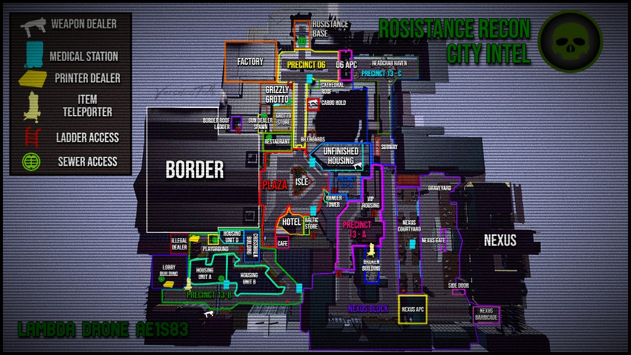

**We can add this map picture and make plugins to show information about every area on the about us page of the website.**

**The Discord channels integration can be done with a plugin on copy paste on the about us section and tutorials section of the website.**

■

■▬▬▬▬▬▬▬▬▬▬▬▬▬▬▬▬▬▬▬▬▬▬■

# **[#2] – PLANNING DEVELOPMENT**

■▬▬▬▬▬▬▬▬▬▬▬▬▬▬▬▬▬▬▬▬▬▬▬▬▬▬▬▬▬▬▬▬▬▬▬▬▬■

## **[#2-1] – Gantt chart**

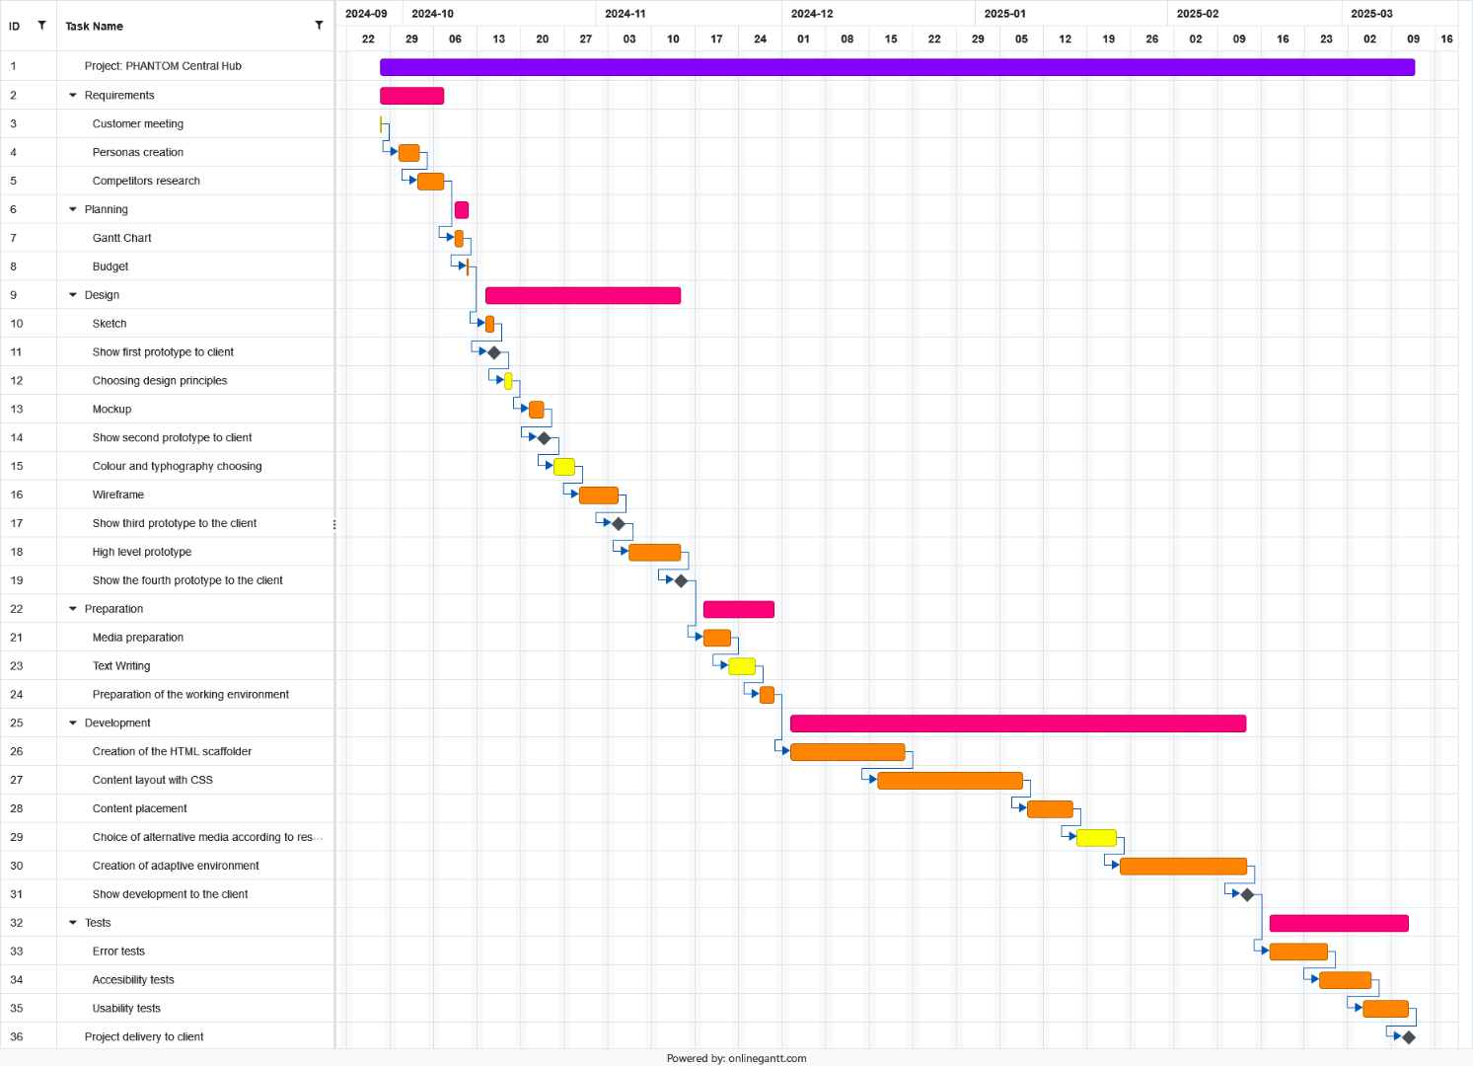**A task plan has been created, outlining the design, planning, development, and testing of the website project called “Phantom Central Hub” over a duration of 6 months, before its final delivery to the client. This diagram already considers the previous information discussed with the client, such as the initial meeting, the requirements gathering, and the current focus, which includes the budget and the Gantt chart. The latter is shown below:**

■▬▬▬▬▬▬▬▬▬▬▬▬▬▬▬▬▬▬▬▬▬▬■

■

## **[#2-2] – Budget**

**After carefully considering the client's requirements and goals for the Phantom Central Hub website during the meeting, a budget has been created in accordance with the client's needs. It includes a fixed price for the complete development and design of the website, as well as a bimonthly fee for ongoing maintenance. These prices have been deemed reasonable for both the client and the developer, ensuring the website's prosperity and proper care.**

|  |  |
| --- | --- |
| **OFFER** | **PRICE** |
| **Complete web design and development** | **16.500€** |
| **Website maintenance** | **2.062,5€** |
| **TOTAL** | **18.562,5€** |

**The fixed price for the project is calculated based on a rate of 600€ per week, with half a week costing 300€. As the Gantt chart shows, the minimum work duration will be 6 months (24th of September 2024 to 12th of March 2025).**

**The website maintenance cost is estimated to range from 1.375€ to 2.750€. The final price may vary depending on three main factors:**

* **Whether the website backups and database saves are up to date to avoid data loss.**
* **The extent to which the website requires frequent updates.**
* **The need for technical support to resolve website-related issues.**

**All these factors can increase the price up to 2.750€. However, if the issue arises from poor programming or a mistake made by the developer during website creation, a 50% discount will be applied, reducing the price to 1.375€ or lower.**

**In the meeting with the client, it was agreed that an initial payment of 63% of the fixed price would be made, which amounts to 6.105€. After the project is completed and fully paid for, the website maintenance payments will begin two months after the website is delivered to the client, and will continue bimonthly until further notice.**

■

■▬▬▬▬▬▬▬▬▬▬▬▬▬▬▬▬▬▬▬▬▬▬■

# **[#3] – DESIGN**

■▬▬▬▬▬▬▬▬▬▬▬▬▬▬▬▬▬▬▬▬▬▬■

## **[#3-1] – Sketch**

**The sketch of Phantom Central Hub is a rough visual plan that helps visualize the layout, hear the client opinions, improve the user experience, save time, and clarify the content hierarchy. It serves as a “blueprint” for the design and development process, allowing for early feedback and adjustments before choosing design principles and creating the mockup.**

**Now, the sketches for this website will be described below.**

1. **LANDING PAGE:**

**This first sketch has a simple design to attract new users.**

**The page includes a predefined header with the website's logo and title, Log In and Register buttons in a dropdown menu, four buttons to navigate to other pages, and a footer with a certification mark from the Senior Ranks of Robine to make the page official, links to the About Us page, additional information (via a Google Drive link), and up to four social media buttons.**

**The main section features a title inviting users to join, options to log in or register, and a description explaining the PRAS system to help new users understand it.**

1. **HOME PAGE:**

**This next sketch is the home page after logging into Phantom Central Hub.**

**This page features a predefined header and footer (like the rest of the pages). The account is logged in, showing the profile picture, name, additional information about the account, and a link to the PRAS system to check out achievements, all in the dropdown menu.**

**In the main section, there is an announcements/news area with a background image (currently drawings). Below there are the announcements sorted by version, each accompanied by images, and a call to action at the end of each announcement saying, 'JOIN US NOW!' with a link button to the PEP or events page.**

1. **EVENTS**
   1. **ACTIVES:**

**In this Events page, all the events currently taking place can be seen.**

**It features the predefined header and footer. In the main section, there is the title of the page along with a description stating that this is the active events page. Below, the events are displayed with the host’s name and profile picture, the event name, an 'ON AIR' text with red glowing circles, and a JOIN button directing you to the game.**

* 1. **SCHEDULED:**

**This page is the same as the one from before but is designed for events that are going to occur in the future.**

**It features the predefined header and footer. The changes in the main section include a description under the title stating that this is the scheduled events page. Instead of the 'ON AIR' text, there is a date for the event, and instead of the JOIN button, there is a Reminder button to receive notifications about the event directly to your email.**

1. **COMMUNITY MENU:**

**This Community menu serves as a hub for all the activities that the Phantom community offers, such as Polls, Tutorials, Chats, and Dev's Work.**

**It features a predefined header and footer. On the main section there is a title that reads 'OUR COMMUNITY' displayed against a background image (currently drawings). Below, the menu is divided into four sections, and each of these subpages includes a description before clicking to enter. The sections are the Polls page, the Tutorials page, the User Communication page, and the Dev Page; however, the last one needs verification because I’m not a developer of the game or of Phantom.**

* 1. **POLLS:**

**In this subpage of the community, users can ask the community what they would like in different contexts.**

**It features a predefined header and footer. In the main section, there is the title of the page with images (currently drawings) displayed in the background. Below, there are user polls with their names and profile pictures shown, asking the community various questions. Each poll includes a valid checkmark and a negative checkmark, along with a number indicating how many people clicked on each option. Some polls also allow for inserted images.**

* 1. **TUTORIALS:**

**In this community subpage, there are tutorials and guides related to the game and the roleplay aspect.**

**It features a predefined header and footer. In the main section, there is the title of the page with images (currently drawings) displayed in the background. Below, the tutorials are sorted by STEPS, which is a thoughtful approach to encourage users to read all the tutorials to become great members of Phantom and skilled players of the game. Each Tutorial Step includes a video explanation.**

* 1. **DEV PAGE:**

**This page is exclusively for developers to collaborate on maintaining Phantom and developing new features, as well as helping with bugs, glitches, and various issues, fixing them and receiving feedback and rewards (monetary) for their efforts.**

**It features a predefined header and footer. In the main section, there is the title of the page. Below, there are two dropdowns for a developer’s chat and a multimedia section where developers can upload their work (links, images, videos, files, etc.), these two dropdowns are shown on the sketches. There is also a report and feedback section for developers to view issues that need to be fixed, which may be technical or related to their games.**

* 1. **USER PAGE:**

**This is the User page, which also contains communications for the chats you own and the friends you have earned. This page is designed to manage your user experience and includes the phrase 'be a gossip with your mates,' as the website developers chose to term it. It also displays the PRAS achievements for you to view.**

**It features a predefined header and footer. In the main section, there is the title of the page with images (currently drawings) displayed in the background. Below, there are two dropdowns for chats and friends, which can indicate whether they are online or offline, these two dropdowns are shown on the sketches.**

**Additionally, there is a profile section that includes the banner or background colour/image of the profile, the profile picture, the nickname, the email for contact, an about text for the user to describe themselves, and an edit button to rewrite all the information about the user. Below this, there is the PRAS achievements section that shows the awards you have earned along the way as a user on the page, along with the percentage of users who own each award and the name of each award. If you click on a locked award, a pop-up will display instructions on how to unlock it; if it’s locked, you cannot see the percentage of people who own it or its name. There is also a share button to share your progress with your favourite friends.**

1. **ACTIVITY SWEEPS:**

**This last page is designed for users who want to know their roleplay points like Recommendation Points (RP) for promotion, as well as for those who have failed and may be subject to punishment. There is also a Wall of Fame featuring images (drawings) for the ranking positions of individuals who have patrolled the most, excelled in shooting, or are recognized as the best in the community, among other roleplay-related surplus.**

**It features a predefined header and footer. In the main section, there is the title of the page with images (currently drawings) displayed in the background. Below, there is a chart for the quota of each unit/user of Phantom (this could be an Excel import). Below that, there is the Wall of Fame section with the rankings mentioned earlier.**

1. **ABOUT US:**

**And last but not least, the About Us page showcases the story, the collaborators, and the creators of this roleplay subgroup of Robine. It features a trailer for the roleplay, as well as a map (that didn’t fit entirely) of the main game that highlights each area. When you click on an area, a pop-up should display the area name, an explanation, and images or gameplay demonstrations. There is also Discord integration, similar to what is found in the tutorials section, although it didn't fit into the sketch. Nonetheless, it will be included on the website.**

**It features a predefined header and footer. In the main section, there is a styled title of the page with images (currently drawings) displayed in the background. Below, you will find the elements in the same order as stated before.**

**After the descriptions of each sketch, the images of the mentioned sketches are shown on the following pages:**

**1:**

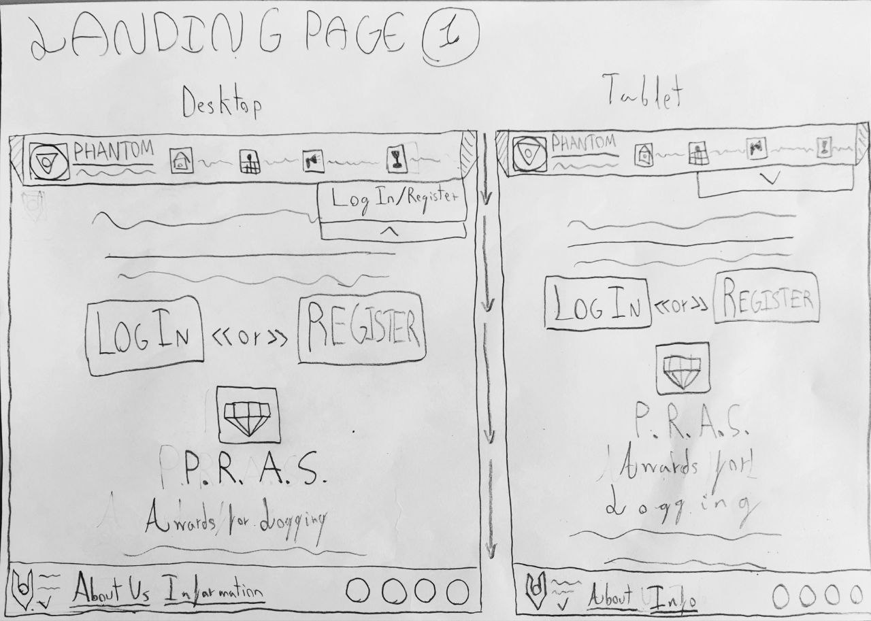

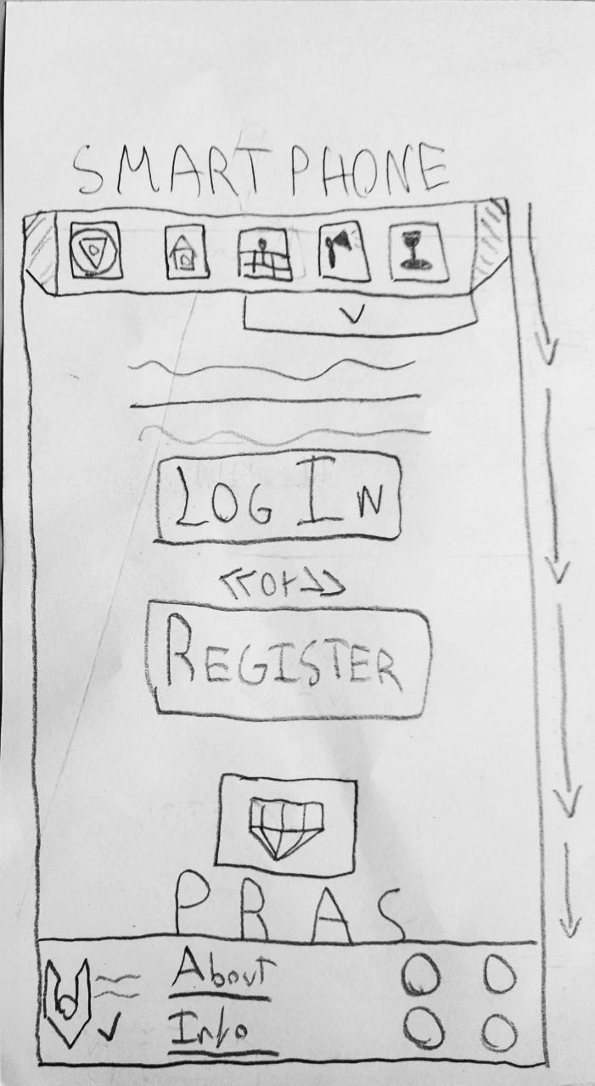

**2:**

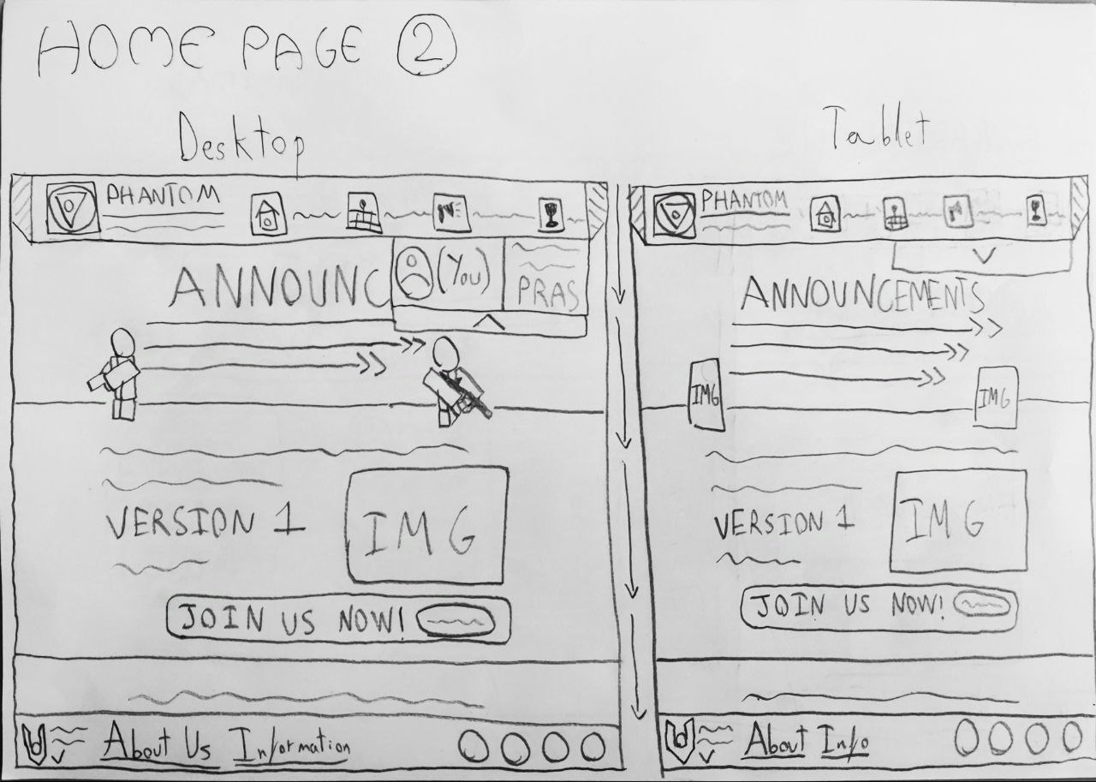

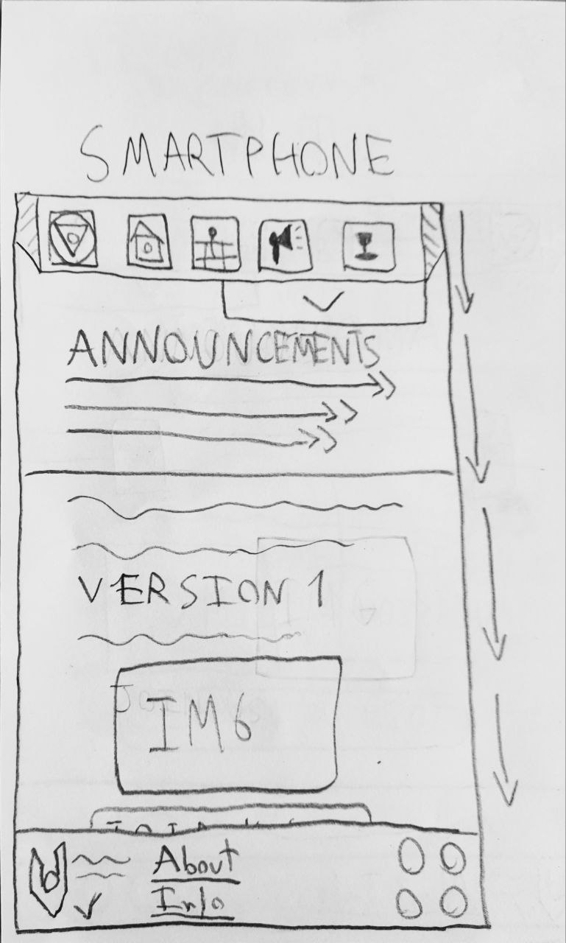

**3.1 (3):**

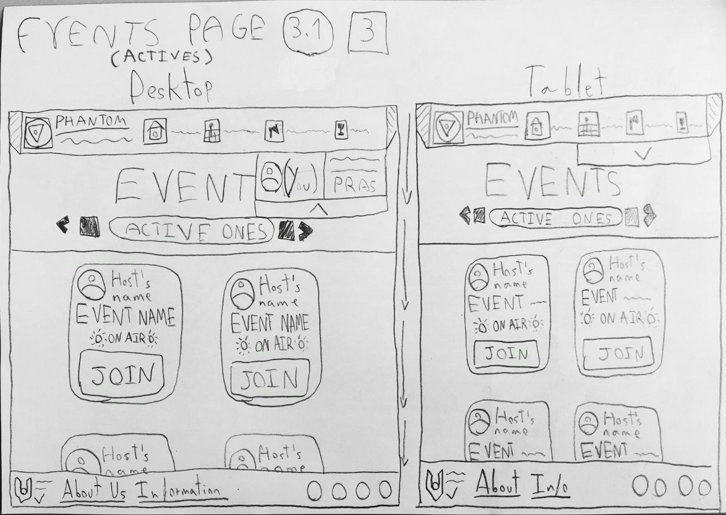

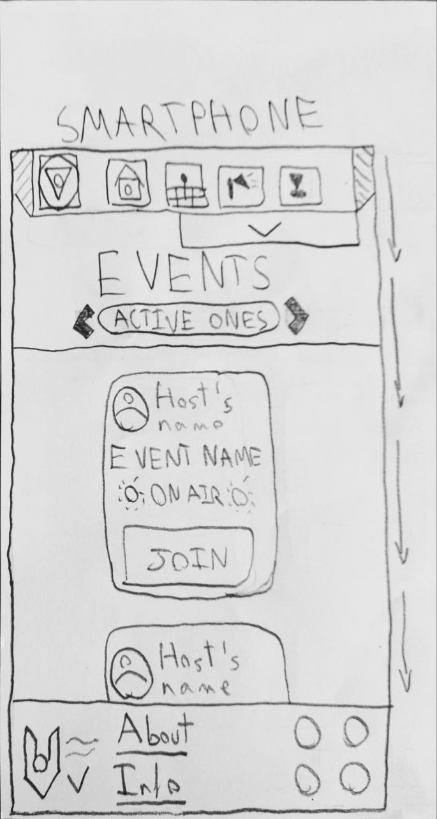

**3.2 (3):**

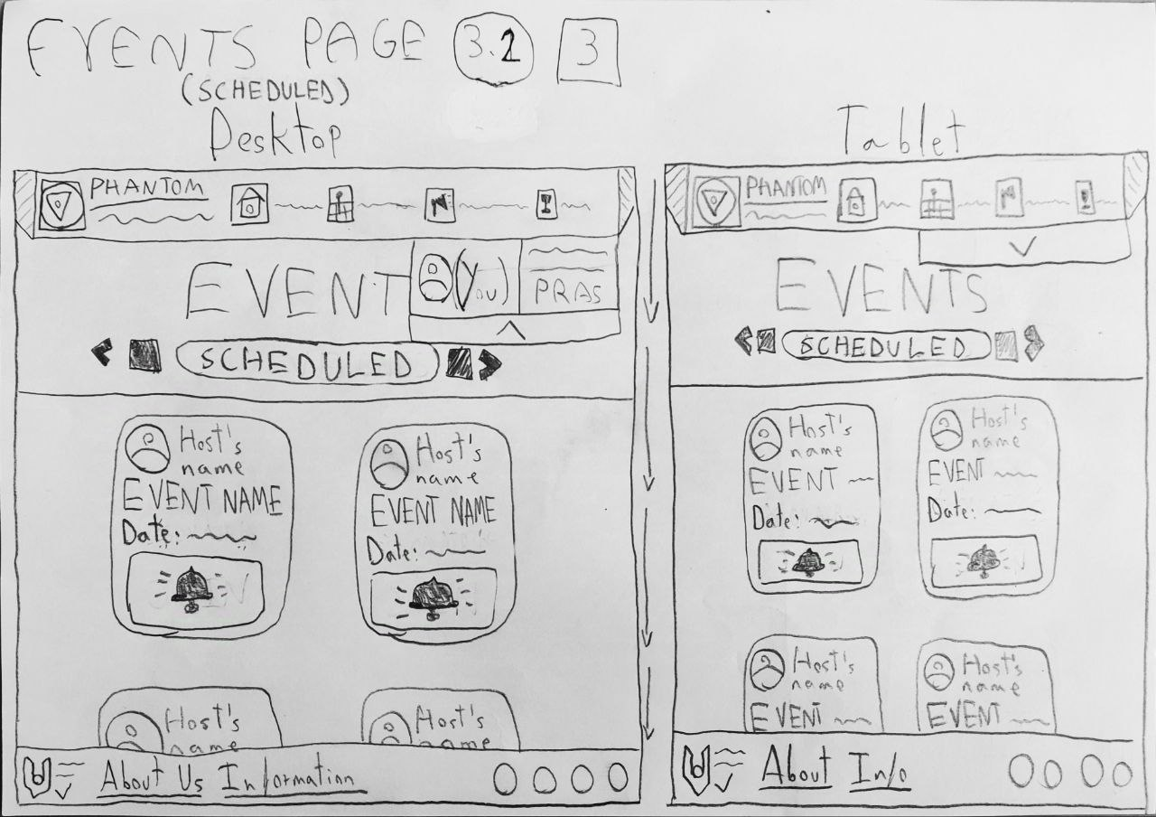

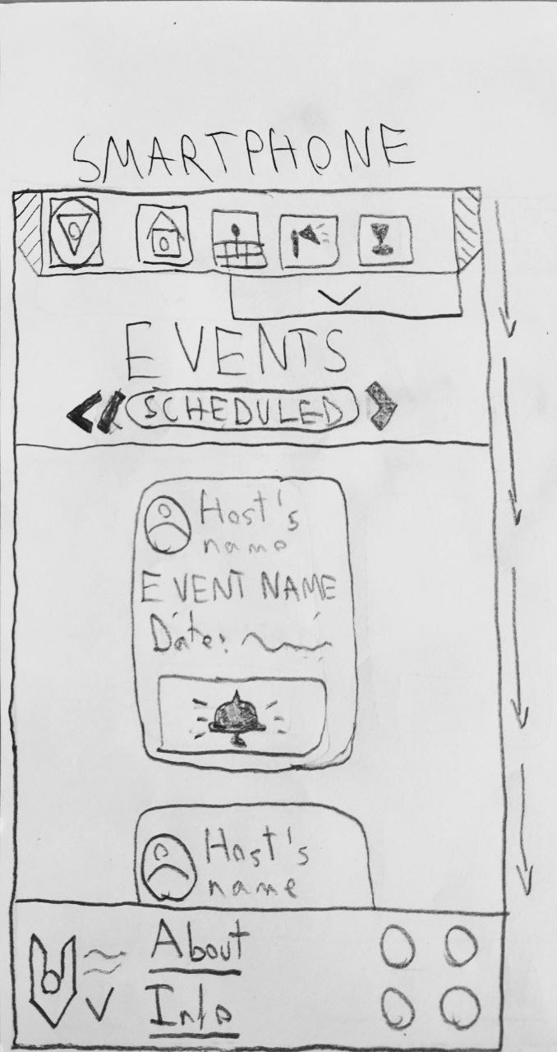

**4:**

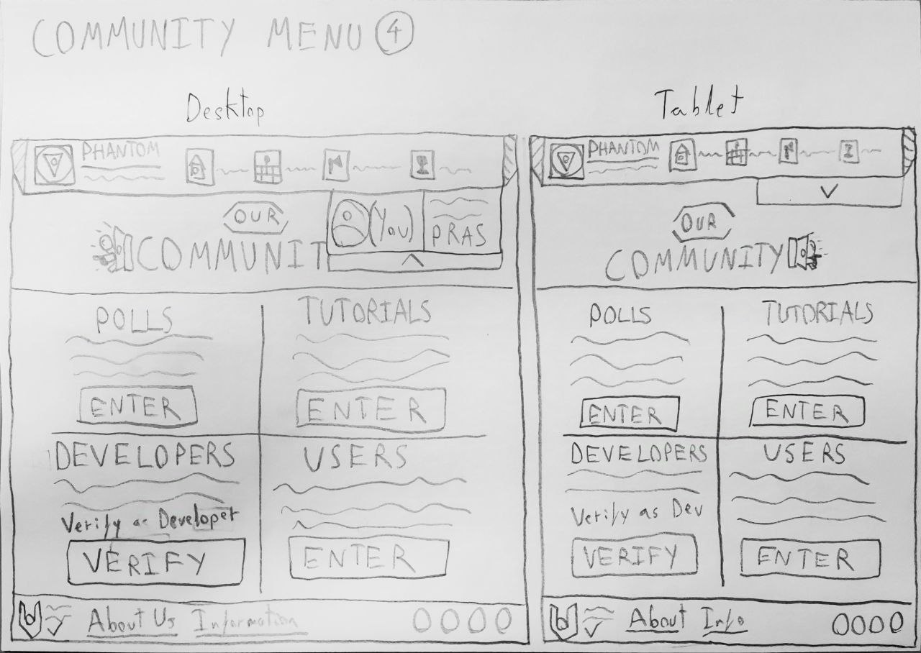

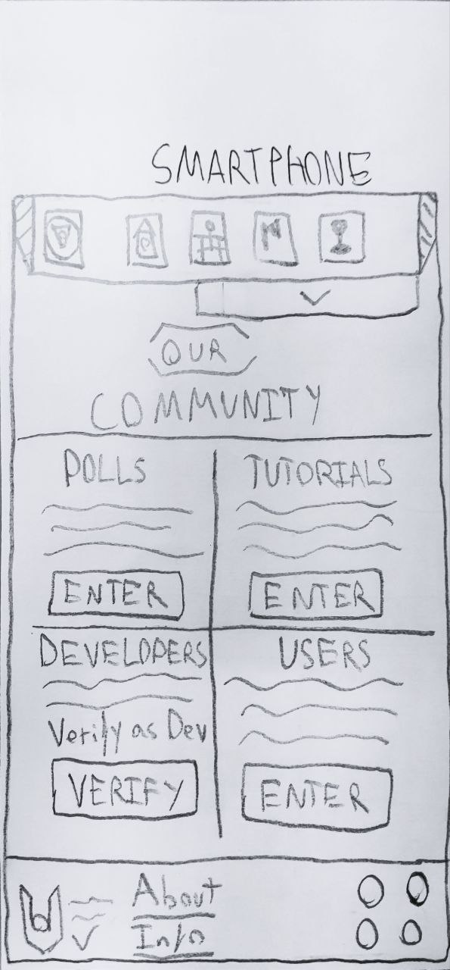

**4.1:**

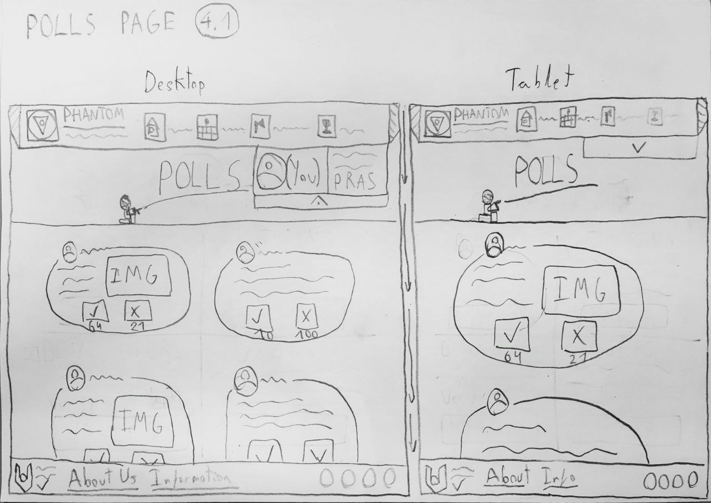

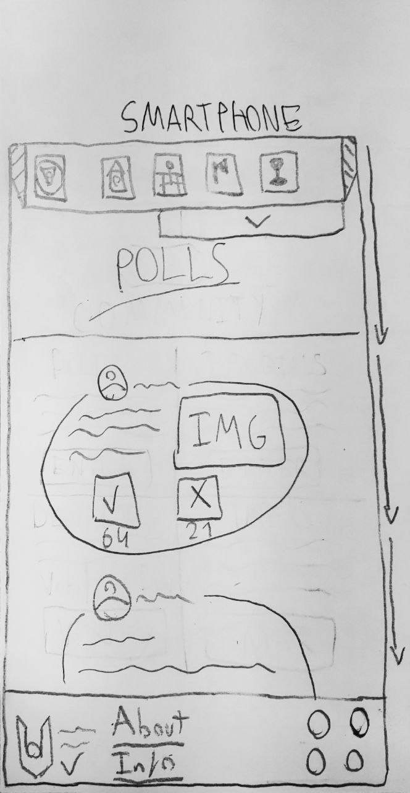

**4.2:**

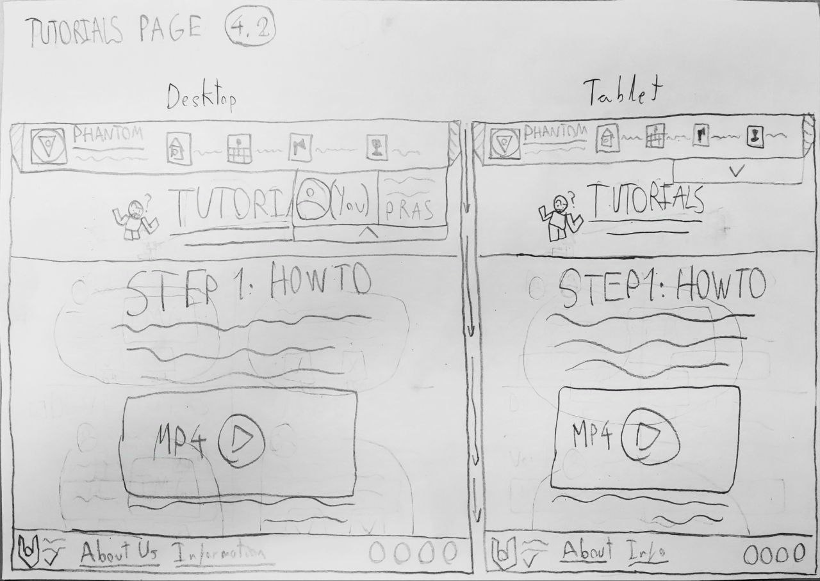

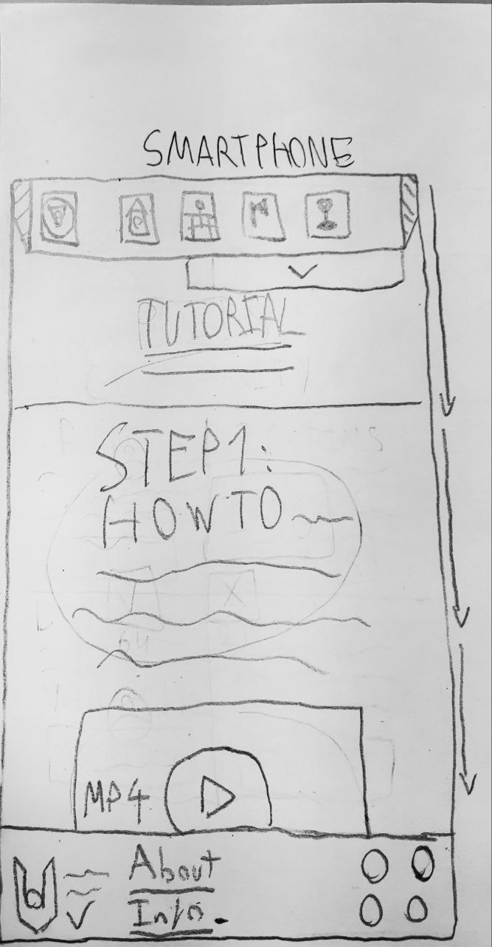

**4.3:**

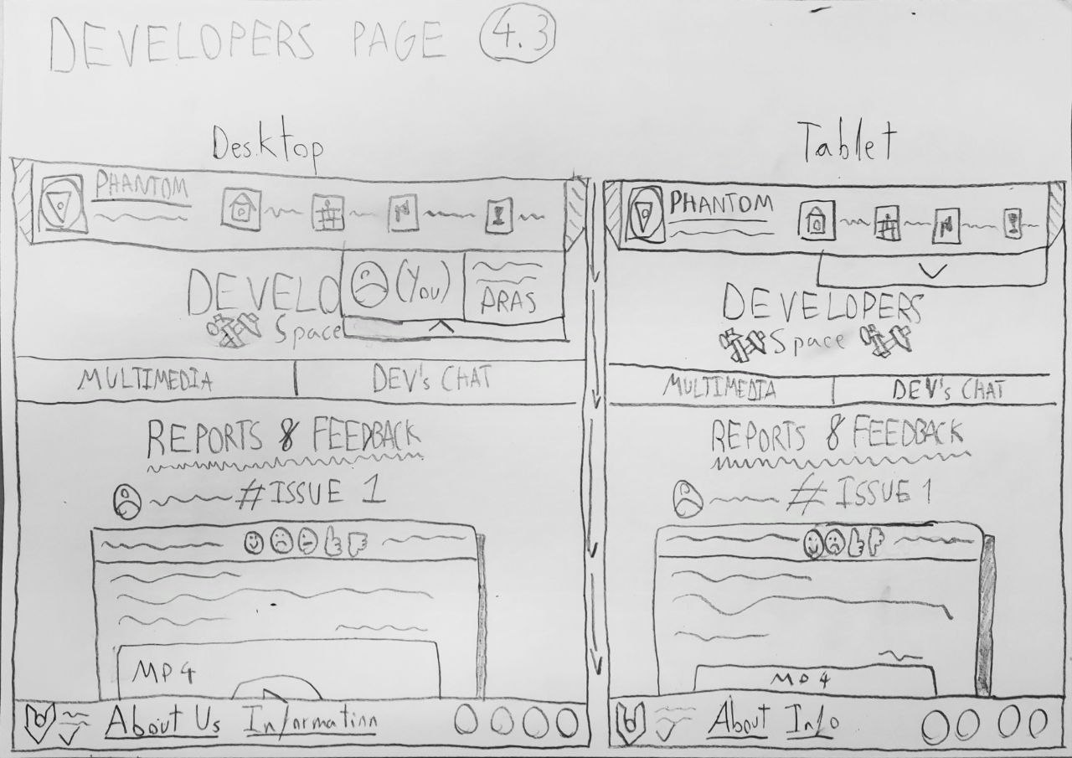

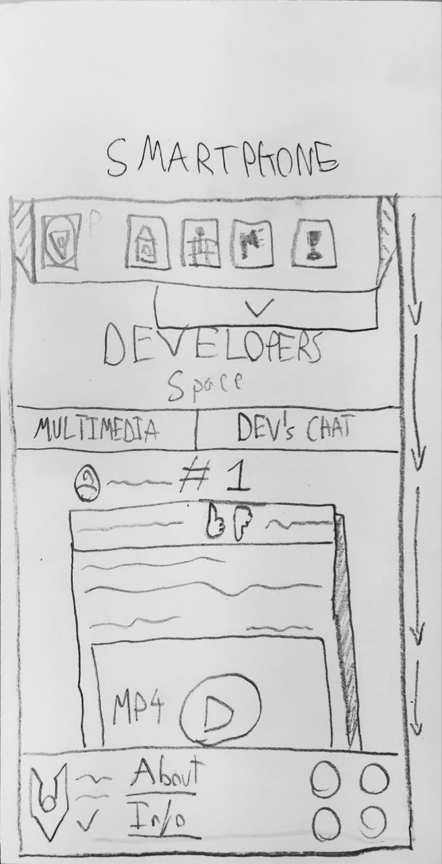

**4.3 (Multimedia):**

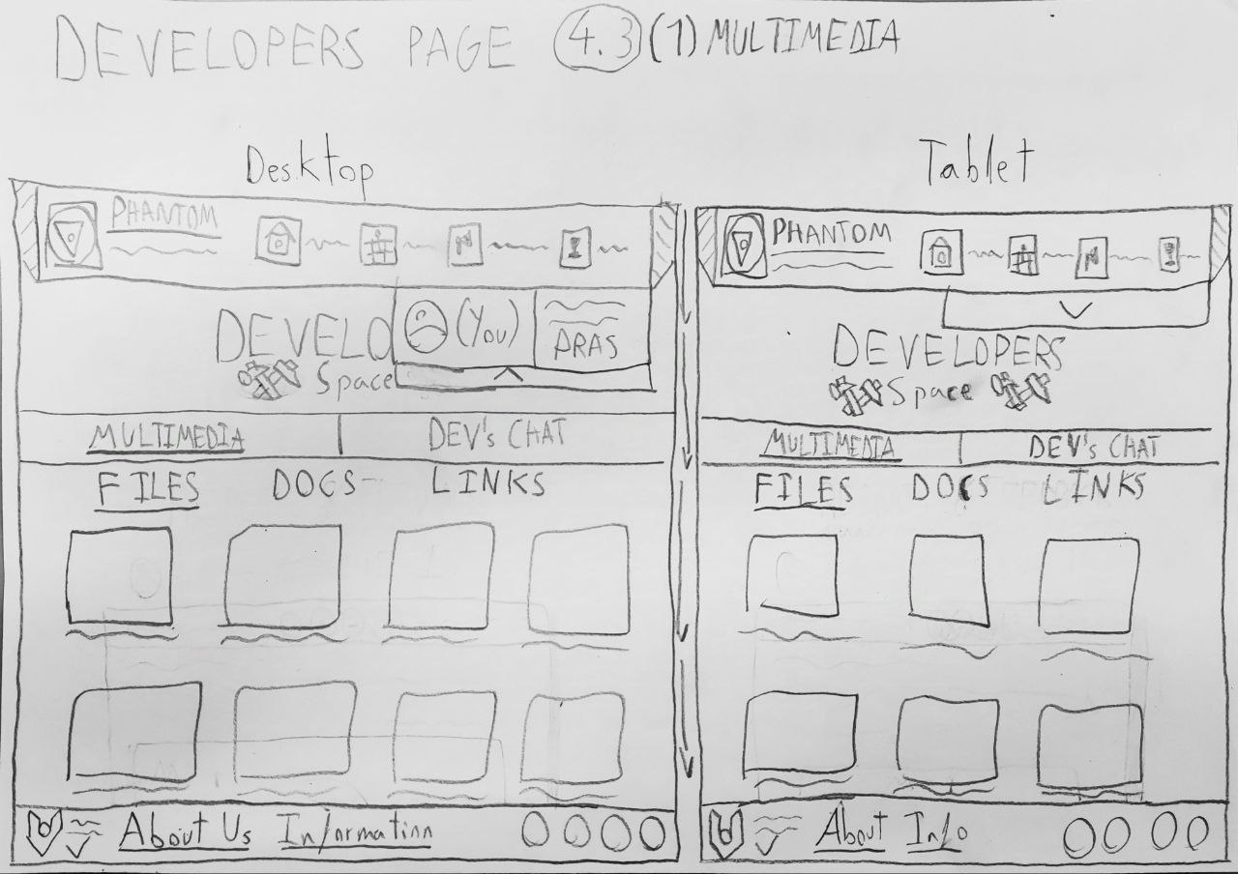

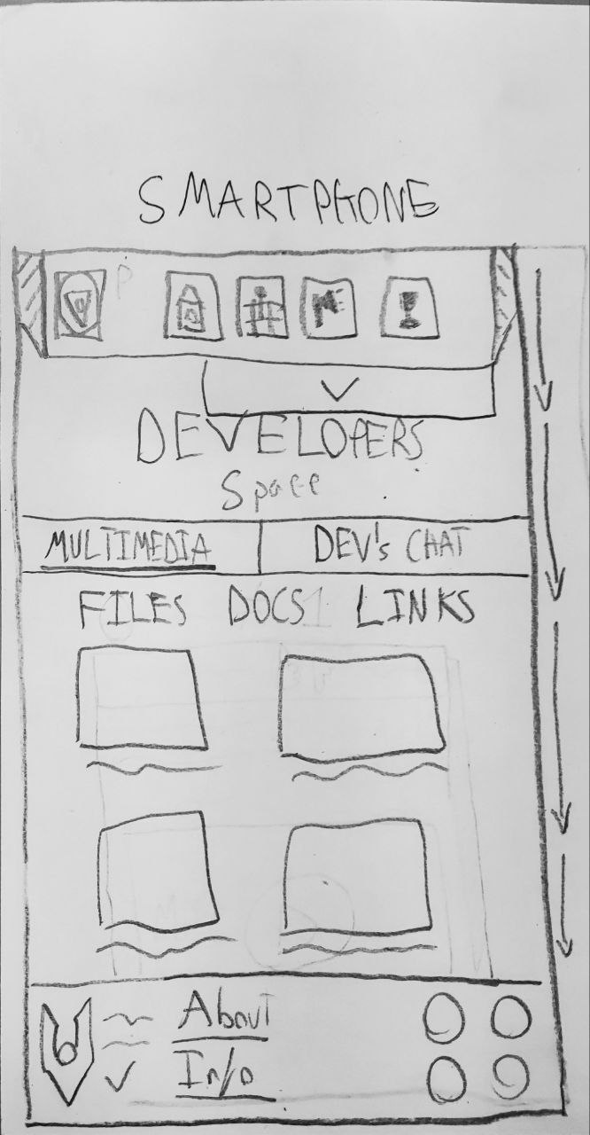

**4.3 (Chat):**

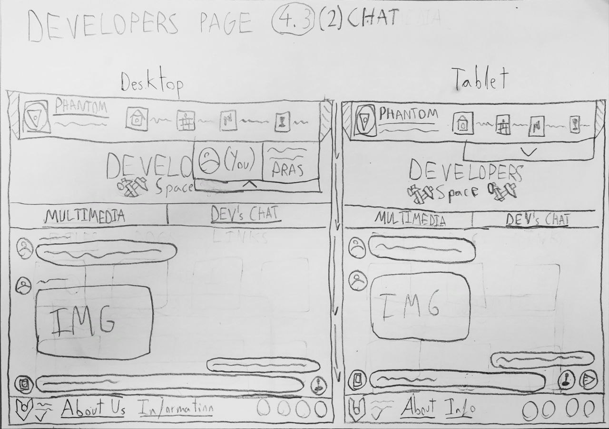

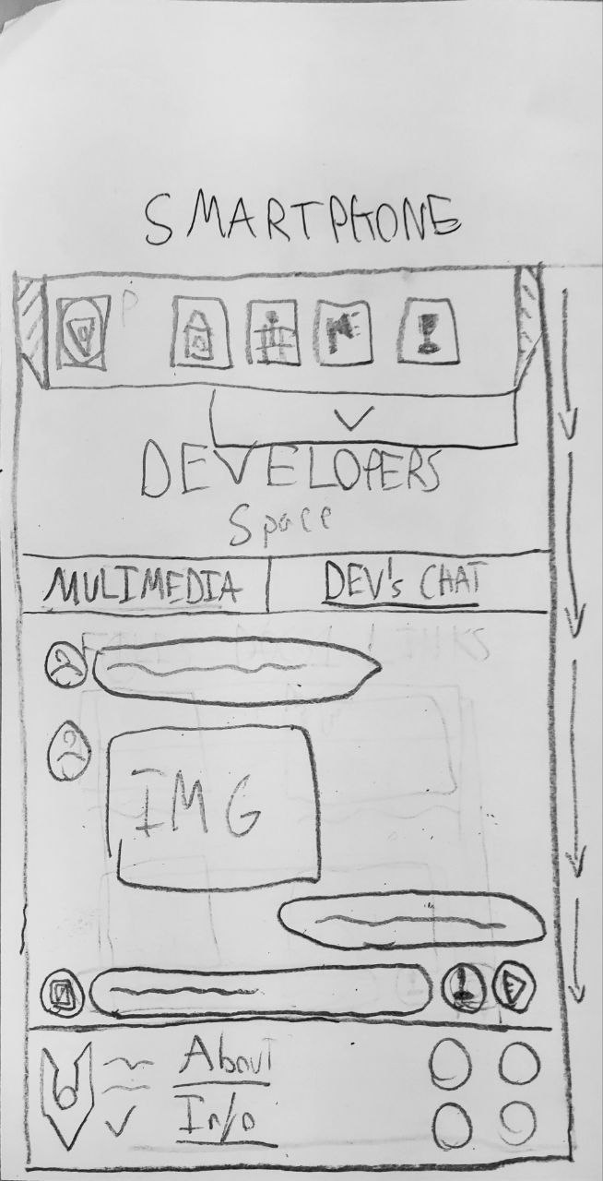

**4.4:**

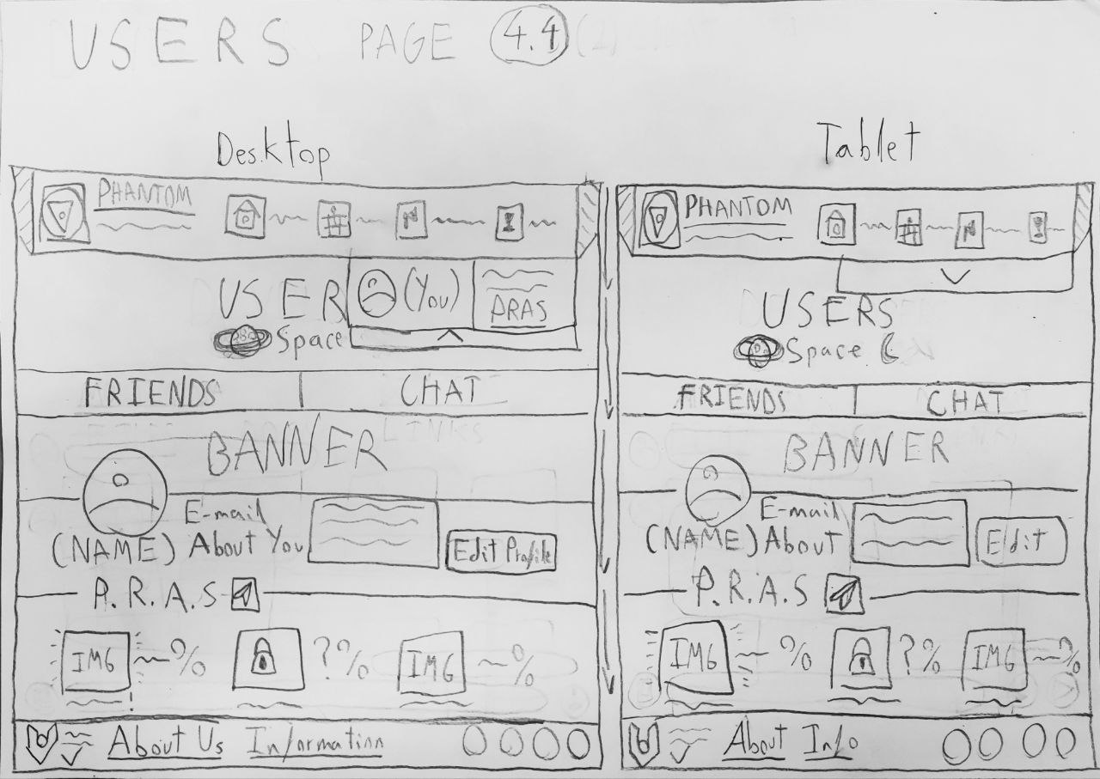

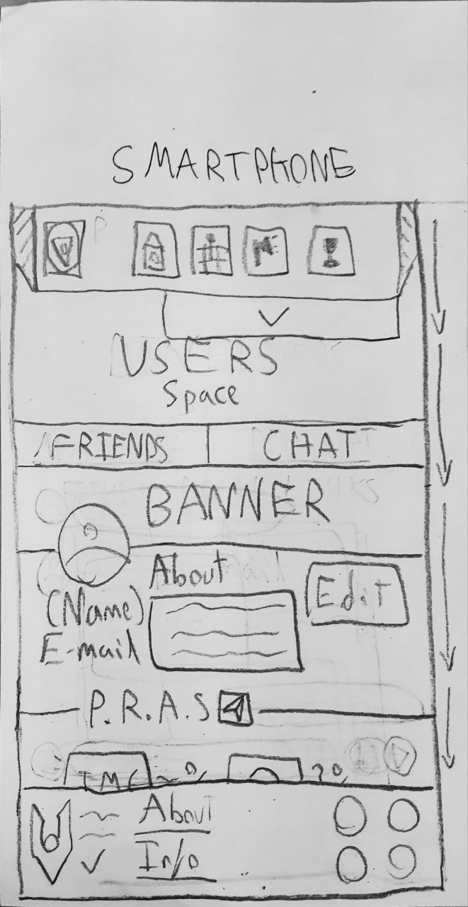

**4.4 (Friends):**

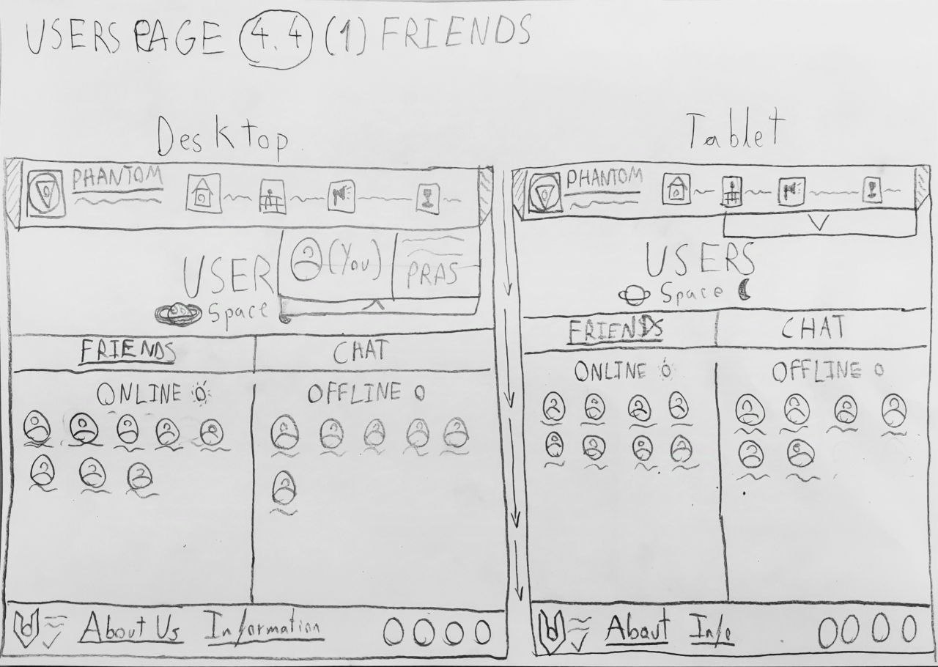

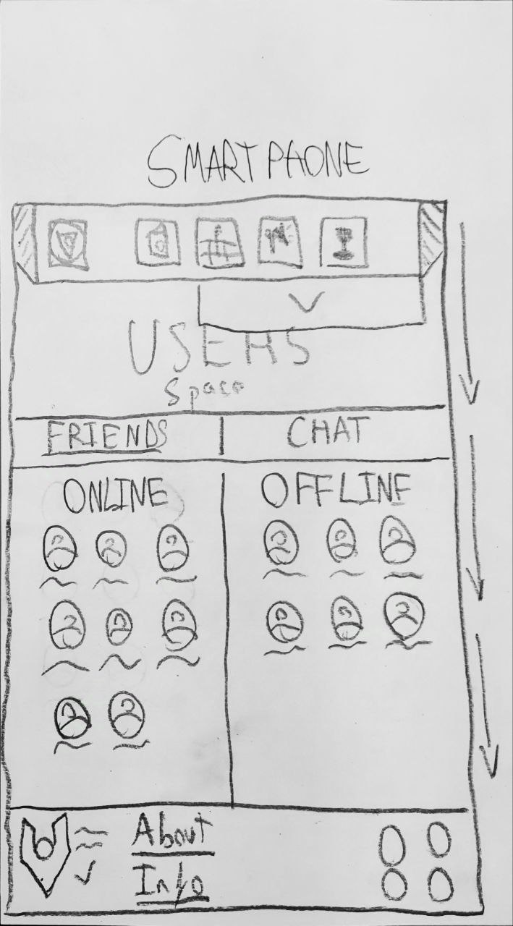

**4.4 (Chat):**

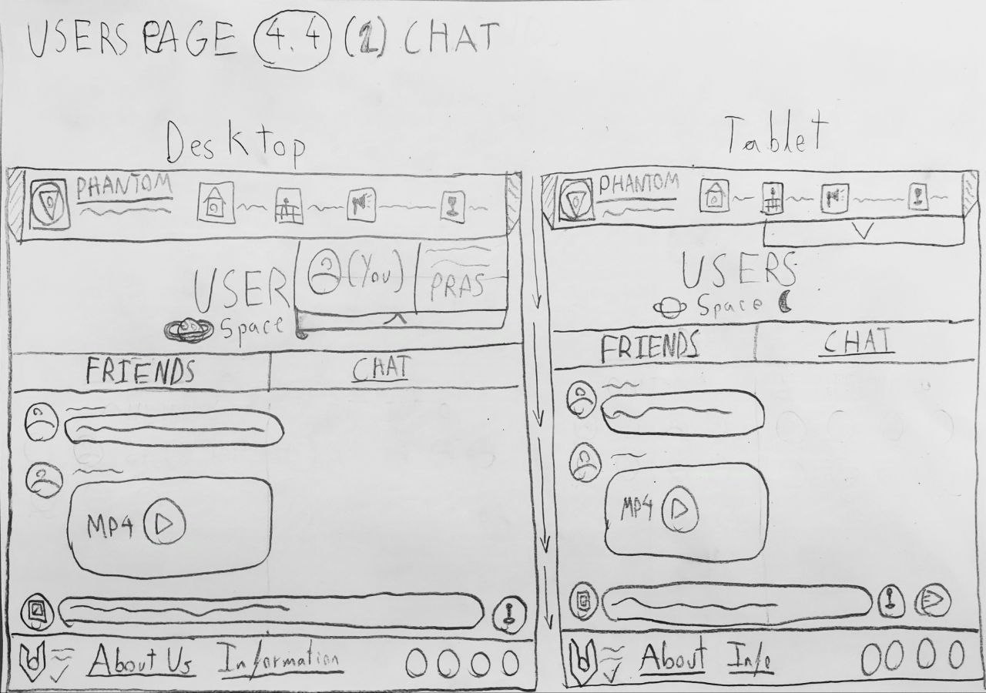

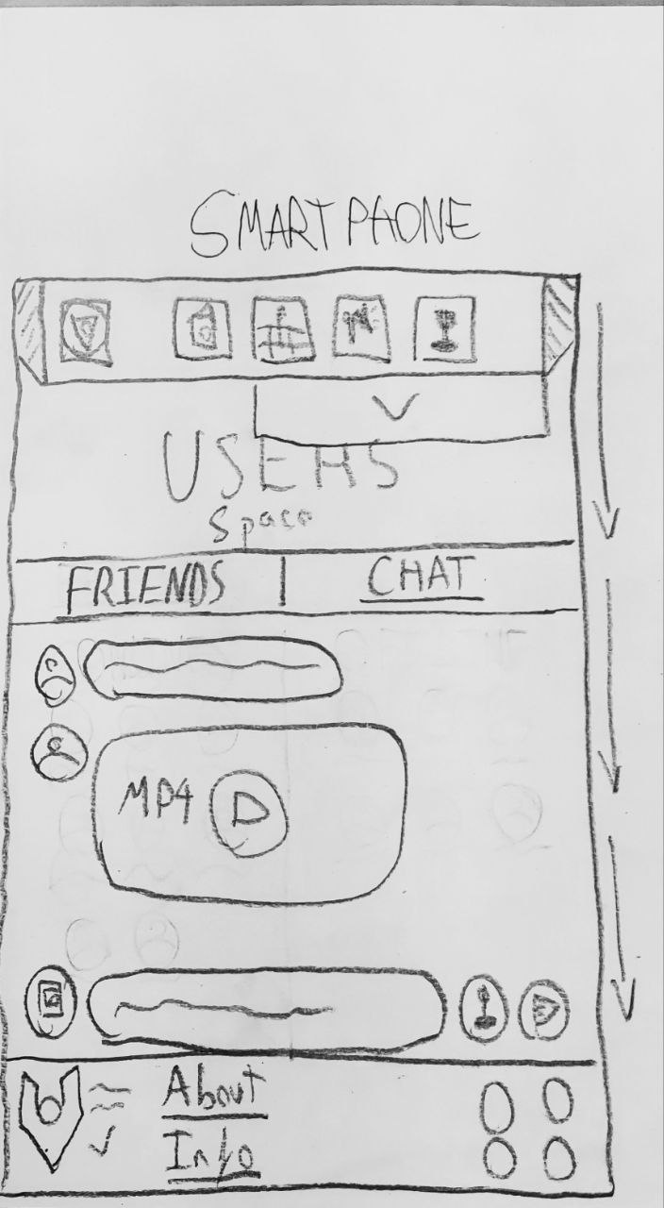

**5:**

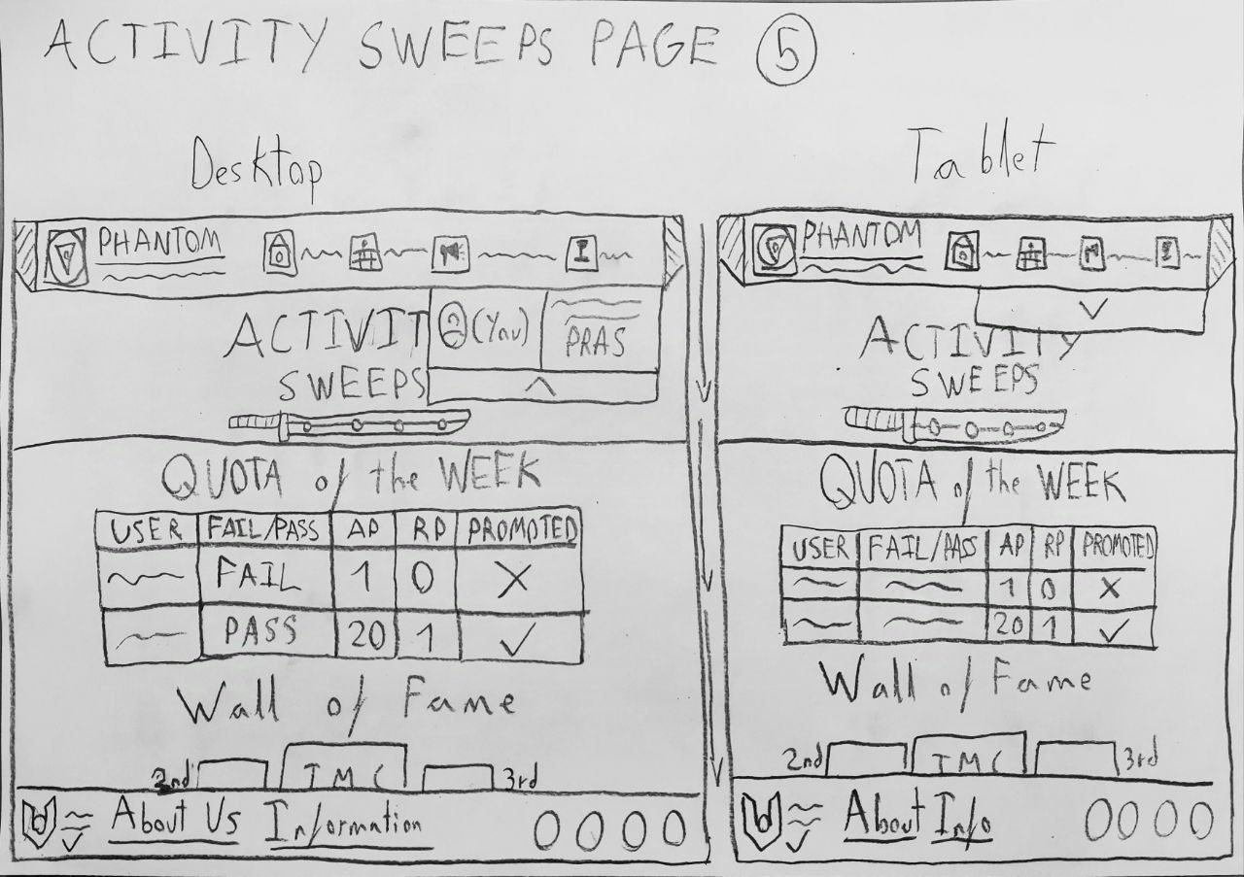

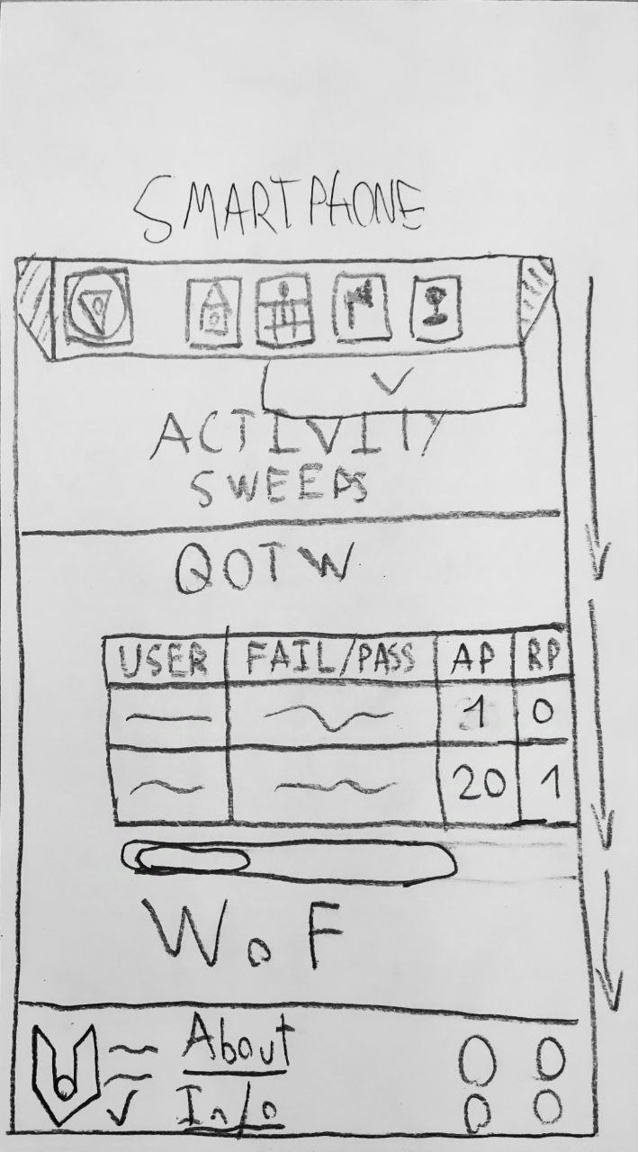

**6:**

